**PROJECT REPORT**

**SMART RFID KAMSIS SYSTEM AT PTSS**

NURUL IZZAH `ATHIRAH BINTI ZAMURI 18DDT18F1075

MUHAMMAD HAFIZ BIN ZAKARIA 18DDT18F1075

**DEPARTMENT OF INFORMATION TECHNOLOGY & COMMUNICATION**

POLITEKNIK TUANKU SYED SIRAJUDDIN

JUN 2020

SMART RFID KAMSIS SYSTEM

**Table of Contents**

PAGE

1.0 PROJECT PLAN

* 1. Introduction 1
  2. Problem statement 2
  3. Objectives 2

1.4 Scope 2

1.4.1 System scope 2

1.4.2 User scope 3

1.4.3 Location scope 3

1.4.4 Software scope 4

1.4.5 Hardware scope 4

1.5 Project Significant 5

1.6 Literature Review 5

1.6.1 System 6

1.6.2 Web Based 6

1.6.3 Database 6

1.6.4 System Comparison 7-9

1.6.6 Comparison table 10

1.6 Methodology 11

1.6.1 Introduction 11

1.6.2 Rapid Application Development(RAD) 11

1.6.3 Rapid Application Development Phase 12

1.7 Gantt Chart 13

2.0 REQUIREMENT SPECIFICATION

2.1Functional Requirement 14

2.1Non Functional Requirement 14

2.3 Hardware and Software Requirement 15

2.4System Configuration 16

2.5 Security Requirement /Exceptional Handling 16

3.0 FINAL DESIGN

3.1LogicalDesign 17- 22

3.2 Physical Design 23 - 33

4.0 TEST DESCRIPTION AND RESULT

4.1UnitTesting 35

4.2Integration Testing Plan 36

LIST OF FIGURE

PAGE

1.0 PROJECT PLAN

Figure 1.1 Location Politeknik Tuanku Syed Sirajuddin 3

Figure 1.2 RFID Door Lock 7

Figure 1.3 Personal RFID Lock 9

Figure 1.4 Rapid Application Development 11

Figure 1.4 Gantt Chart 13

3.0 FINAL DESIGN

Figure 3.2.1 Login Admin 28

Figure 3.2.2 Student Details 28

Figure 3.2.3 Staff Details 28

Figure 3.2.4 Register Staff 29

Figure3.2.5Facilities Details 29

Figure 3.2.6 Login Staff 30

Figure 3.2.7 Students Details 30

Figure 3.2.8 Facilities Details 31

Figure 3.2.9 Login Student 32

Figure 3.2.10 Info Students 32

Figure 3.2.11 Facilities information 33

Figure 3.2.12 Facilities confirmation 33

4.0 TEST DESCRIPTION AND RESULT

Figure 4.1 Login Staff 35

LIST OF TABLE

PAGE

1.0 PROJECT PLAN

Table 1.1 Software Scope 4

Table 1.2 Hardware Scope 4

Table 1.3 RFID Door Lock 10

2.0 REQUIREMENT SPECIFICATION

2.1 Software 15

2.1 Hardware 15

4.0 TEST DESCRIPTION AND RESULT

Table 4.1 Web System Integration testing Plan 36

1.0 **PROJECT PLAN**

* 1. INTRODUCTION

Tuanku Syed Sirajuddin Polytechnic is an IPTA located in Arau Perlis and is the 18th polytechnic in Malaysia. This polytechnic was formerly known as Perlis Polytechnic. At the polytechnic is a student residential college, every year there will be two semesters of study that take place in December and June.

The warden suggested a system to update the data of each occupant of the room and the inflow and outflow of occupants from the room. The system that is going to be done is based on web based . Meanwhile, the web based helps user register the data such as student can confirm facilities details for check by staff and admin.

There are only 3 users in this system, namely Hal ehwal pelajar(HEP) ,residential college wardens and students

This system is created to overcome some problems that are:

1) Residential college warden: wants to reduce the cost of making locks every semester when there is a loss and negligence.

2) Students: face difficulties if keys are lost and room security is not tightly controlled.

The Polytechnic is committed to providing facilities for each occupant of the room as well as maintaining the safety of occupants in the event of intrusion or unwanted theft.

1

**1.2 PROBLEM STATEMENT**

Each semester the room key will be reduced among residents kamsis because lost and negligence. This is a problem for the warden kamsis as difficult for a new manufacturing process for the next semester because each semester will turn new residents.There are some significant negative consequences if a key is not returned or are lost due to the negligence of both parties. One effect is the warden had to create a new key so that new residents can enter the room.

**1.3 OBJECTIVE**

The main objective of SMART RFID KAMSIS SYSTEM AT PTSS.

**- to manage room facilities information**

**- to control room authorization**

**- to alert users about unlock doors**

**1.4 Scope**

There are 5 types scope such as system scope, user scope, location scope, hardware scope and software. Below is the explanation for five scopes.

**1.4.1 System Scope**

System scope that we are developing by using Net Bean IDE, Java, Arduino IDE, Xammp server Mysql. This system is help the warden of the kamsis politeknik to update room Student and access matrix cards as room keys.

There are three types of users in this system.Each of the user will have its own functionality. Admin be able to add or remove data occupants with using the system for each semester.Also, able to reset username and view all the updates that is updated by the admin. Second,Warders can view the students details and approved the fee student to access cad matrik as a key.

Third is room occupants. Room Occupants can confirm the facilities room and view own information.

2

**1.4.2 User Scope**

I) Admin

HEP is the admin of the system.The admin of the company is able to update,add and remove user of the system

ii ) Staff

Warden kamsis is the staff of the system.The staff can view student info and approved the fee.View all facilities information in student room.

iii ) Student

Student is able to open the door with matrik card.Also, can view the key is open or closed using web based.Can update information about Item in room.

**1.4.3 Location scope**

This system will implement at Politeknik Tuanku Syed Sirajuddin, Pauh, Perlis.

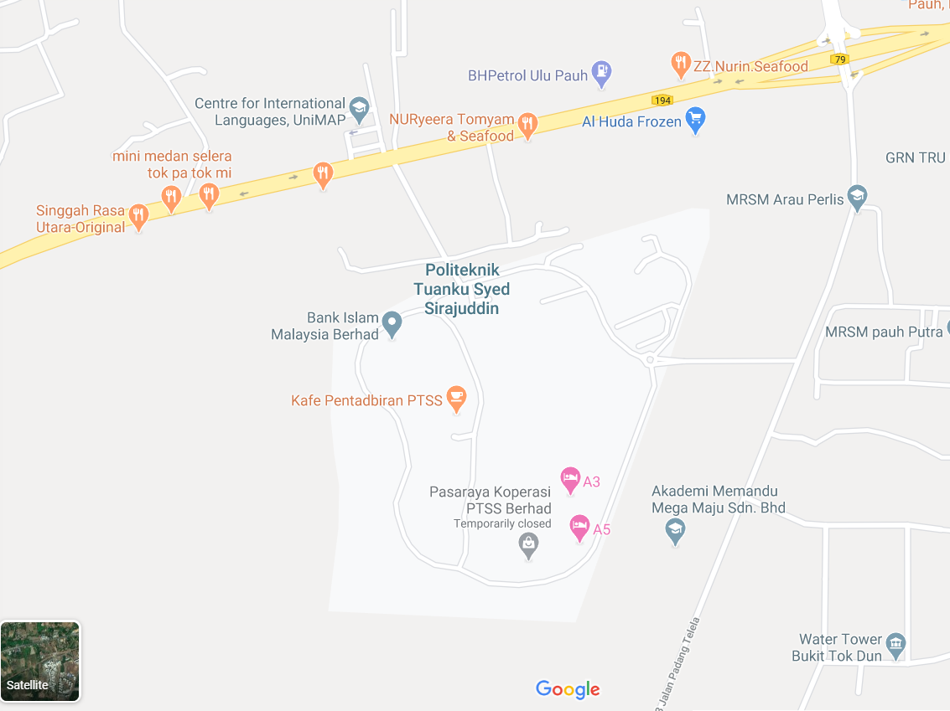

Figure 1.1 Location Politeknik Tuanku Syed Sirajuddin

3

**1.4.4 Software Scope**

To produce this system, there are some software used as in the table 1 below:

Table 1.1 : Software Scope

|  |  |
| --- | --- |
| **Software** | **Explaination** |
| Arduino IDE | Program And set up Arduino Uno |
| NetBean IDE | To create web based interface |
| Xammp Server Mysql | Create Database |

**1.4.5 Hardware Scope**

Table 1.2 : Hardware Scope

|  |  |
| --- | --- |
| Hardware | Explaination |
| 1. Arduino uno | perform the same action multiple times in a program |
| 1. MRFC RFID522 RFID Scanner | To read RFID card |
| 1. 12V DC Solenoid Door Lock | electrical locking and unlocking |
| 1. Nodemcu EPS8266 | To control a digital output |
| 1. 2Channel Isolated 5V Relay(BT13-003) | allows a relatively low voltage to easily control higher power circuits |
| 1. Mini breadboard | make quick electrical connections between components |
| 1. Jumper cable 150mm | open or bypass part of an electronic circuit |

4

**1.5 Significant Project**

This Smart RFID kamsis saves time and reduces the cost of resetting the lock in the event of a loss while providing a better solution for the safety of each occupant of the room. Admin will update and delete the occupant data staf and student.Second, staff can view students details and approved student fee. Third, Student can confirm the facilities room at web based. If in one room there are 2 occupants, only the 2 occupants can access the rfid lock system .User can use web based to acces the system.

**1.6Literature Signifiant**

The main purpose of the literature review is to study the problem and assess the existing system, or any activity related to the projects to be developed. Collect information about the Smart RFID Kamsis Lock Door system, the system requirements and priority system should also be investigated. An interview with Warden Asrama Politeknik Tuanku Syed Sirajudin has done to collect information and to understand the Student,s requirements. Knowledge of kamsis key system information can also be gathered from observation and interview sessions.It will be easier for programmer to develop Smart RFID Kamsis Lock Door system.

Kamsis Politeknik Tuanku Syed Sirajudin have own record system ,so records on Website Ikamsis to book a room is the only method used for students to record all personal information and room information.

Moreover, comparisons between previous room lock systems can in Kamsis Politeknik Tuanku Syed Sirajudin also helps the developer to get some idea to determine the functions in new system

Furthermore, the study of literature is important in developing a project. It is done to collect various information related to the project in which this information will serve as guidelines and provide a clear picture of the project to be develop.

5

1.6.1 System

System design includes activities to conceive a system that answers an intended purpose, using principles and concepts, it includes assessments and decisions to select elements that compose the system, fit the architecture of the system, and comply traded-off system requirements. System design is the complete set of detailed models, properties or characteristics described into a form suitable for implementation .

The main System of RFID Kamsis system is use the database from Student,that can access by Admin(HEP) and Warden(staff).If Room has been book by Student ,the lock door will manually set up information about that student’s.

1.6.2 Web Based

System design includes admin interface on Web Based to access and update student information, admin can remove and add room occupants at any time. If the student break the rules on Kamsis , then the warden (staff) deserve to remove or warn the occupant of the room.Warden can access about item in every student room.

1.6.4 Database

Smart RFID Kamsis is use Xammp server Mysql that can access by web based and mobile application

6

**1.6.5 System Comparison**

*RFID Door Lock System*

1. The arduino based RFIDdoor lock system is secure and responsive as compared to other systems. Withthe use of arduino, it becomes much easy to design. Program a code and uploadit to arduino just like a plug and play device. It is simple and cost efficientproject and can be used as a basic access control mechanism. Their main advantageis contactless communication and RFID tags can work in any environmentalconditions. This is the reason RFID systems are more efficient

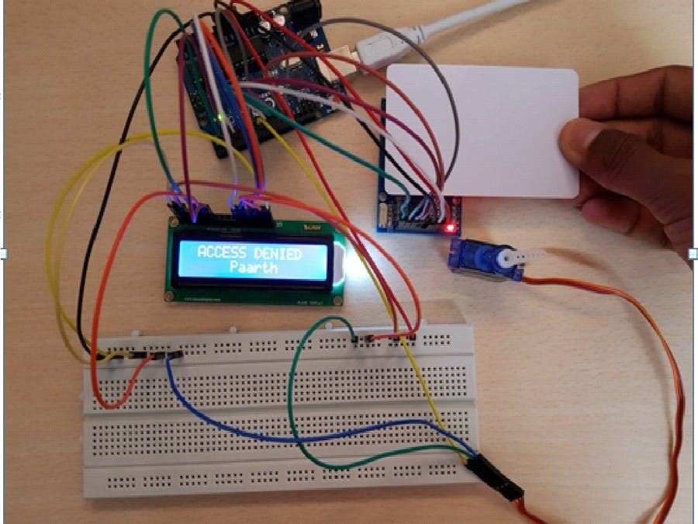

Figure 1.2 RFID Door Lock

1. Advantage:

* User can access use Rfid cad only
* Can acces multiple database

1. Disadvantage

* Cannot connect to mobile phone
* User can connect by rfid can only

7

*RFID door lock Servo motor*

b) Now as the tag is powered it can extract the transmitted message from the reader, and for sending message back to the reader, it uses a technique called load manipulation. Switching on and off a load at the antenna of the tag will affect the power consumption of the reader’s antenna which can be measured as voltage drop. This changes in the voltage will be captured as ones and zeros and that’s the way the data is transferred from the tag to the reader.

There’s also another way of data transfer between the reader and the tag, called backscattered coupling. In this case, the tag uses part of the received power for generating another electromagnetic field which will be picked up by the reader’s antenna.

1. Advantage

* Character display

1. Disadvantage

* Servo motor is not strong enough to lock the door
* The door can’t be access if rfid card missing.

8

*Personal RFID lock*

c) An RFID based Door Lock is based on some simple concepts. We store a set of RFID card data in our system, say 3 or 10 RFID card data. When the person with the right RFID card (compatible to data preloaded in our program/system) come and swipes his RFID tag, access will be granted. When the person with the wrong RFID card (whose data is not loaded in our system) swipes his RFID tag, access will be denied. I hope you understand the system concept of RFID based Door Lock

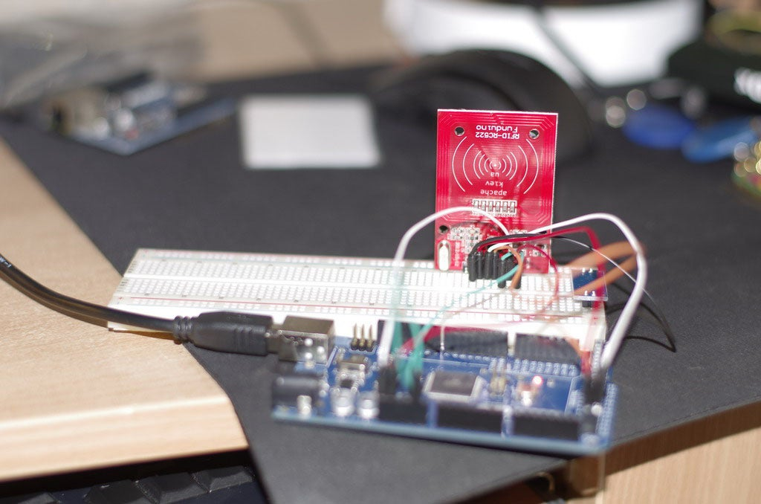

Figure 1.3 Personal RFID lock

1. Advantage

* User easy to access by RFID Card Only
* No more key to open the door

1. Disadvantage

* Don’t have multiple user database
* Can access by rfid card only

9

Table 1.3 RFID Door Lock

|  |  |  |  |  |
| --- | --- | --- | --- | --- |
| System Name  Function | RFID Door Lock | RFID door lock Servo motor | Personal RFID lock | Smart RFID Kamsis |
| Rfid Scanner | **✓** | ✓ | ✓ | ✓ |
| Multiple Database | ✓ | ✓ | ✕ | ✓ |
| Database | Mysql | Mysql | Mysql | Mysql |
| Mobile Application | ✕ | ✕ | ✕ | ✓ |
| Webbased interface | ✕ | ✕ | ✕ | ✓ |
| Notication system | ✕ | ✕ | ✕ | ✓ |
| Character Display | ✓ | ✓ | ✕ | ✕ |
| Log In System | ✕ | ✕ | ✕ | ✓ |
| User information on RFID card | ✕ | ✕ | ✕ | ✓ |

10

* 1. **Methodology**
     1. **Introduction**

Project management teams clung to the traditional approach of strict planning, process, and documentation. Agile management turns this approach on its head, and it’s no wonder that this methodology has become more popular over time. According to a 2017 study from PwC, agile projects are 28% more successful than traditional projects.And project managers have taken notice particularly among teams in industries like software development where technology, objectives, and targets are in constant flux.

**1.6.2 Rapid Application Development (RAD)**

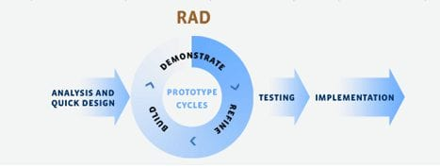The Rapid Application Development (or RAD) model is based on prototyping and iterative model with no (or less) specific planning. In general, RAD approach to software development means putting lesser emphasis on planning tasks and more emphasis on development and coming up with a prototype. In disparity to the waterfall model, which emphasizes meticulous specification and planning, the RAD approach means building on continuously evolving requirements, as more and more learnings are drawn as the development progresses.

Figure 1.4: Rapid Application Development

11

**1.6.3 Rapid Application Development Phase**

Phase 1 – Analysis

In this analysis phase,we choose our Polythechnic for our project at Pauh,Perlis. Then, we make an appointment on 17 august 2020. Then, interview the person in charge of the Kamsis Polythecnic. Ask question about lock system in kamsis .Lastly, list the current problem and find requirement of system.

Phase 2 – Design

In this design phase, create use case diagram to show the functionality of system, create Entity Relationship Diagram (ERD) to represent the data in database, create Data Flow Diagram to show the data flow involved in the system, create context diagram, create storyboard of interface and create interface of system.

Phase 3 – Development

In this development phase, we create web based interface for admin, staff and student’s, create system by using Arduino, create database by using Xammp Server Mysql and create connection database

Phase 4 – Testing

In this phase, will test database and developed a program to access the system built. The system developed will be accessed arduino it can operate perfectly or not. The system will be tested to determine if there is any error in system developed.

12

* 1. **Gantt Chart**

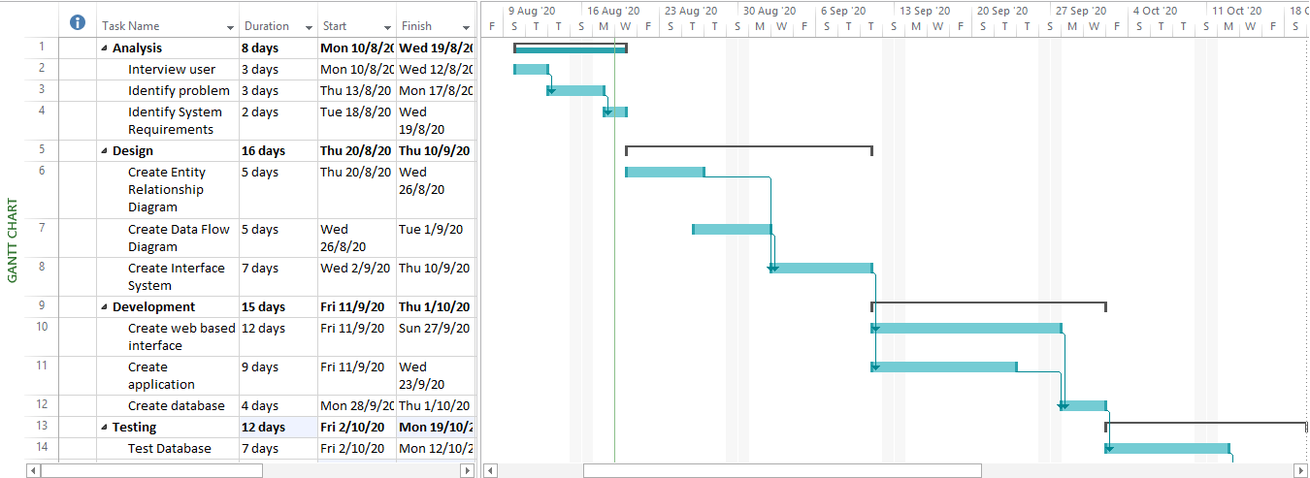

Figure 1.5 Gantt Chart

13

**2.0 REQUIREMENT SPECIFICATION**

**2.1 Functional Requirement**

A Functional Requirement is describes the functions a software must perform. A function is nothing but inputs, its behavior, and outputs. It can be a calculation, data manipulation, business process, user interaction, or any other specific functionality which defines what function a system is likely to perform.

1)Register Student - Admin register students who get kamsis.

2)Confirm Fee - The staff receive fee payment slip and approved fee.

3)Student is able to open the door with matrik card.

- Log into the system.

- Admin register students.

-Admin register staff.

- Admin update and delete students.

-Admin update and delete staff.

-admin can view the facilities details.

-staff can view students details.

-staff must confirm the fee for students to acces cad matrik such as key.

-students must confirm the facilities at room.

-Finally,logout.

**2.2 Non Functional Requirement**

A non-functional requirement is a requirement that specifies critiea that can be usedto judge the operation of a system, rather that specific behaviors. they are contrasted with functional requirements that define specific behavior or function. The plan for implementing functional requiremnts is detailedin the system architecture,because they are usually architecture significant requirements.

2.2.1 Reliability

Reliablity is how often does the system experience critical failures and how much time is it available to users against downtimes?

A) The system shall be complete operational at least 80% of the time.

B) Down time after a failure shall not exceed 48 hours.

C) The system must successfully add any register provided by the user and provideestimates and inventory status at in relation to a newly update entity.

D) The system must confirm student fees by staff and access the matrix card as a key.

14

**2.3 Hardware and Software Requirement**

Table 2.1: Software

|  |  |
| --- | --- |
| **Software** | **Explaination** |
| Arduino IDE | Program And set up Arduino Uno |
| NetBean IDE | To create web based interface |
| Xammp Server Mysql | Create Database |

Table 2.2 : Hardware

|  |  |
| --- | --- |
| Hardware | Explaination |
| 1. Arduino uno | perform the same action multiple times in a program |
| 1. MRFC RFID522 RFID Scanner | To read RFID card |
| 1. 12V DC Solenoid Door Lock | electrical locking and unlocking |
| 1. Nodemcu EPS8266 | To control a digital output |
| 1. 2Channel Isolated 5V Relay(BT13-003) | allows a relatively low voltage to easily control higher power circuits |
| 1. Mini breadboard | make quick electrical connections between components |
| 1. Jumper cable 150mm | open or bypass part of an electronic circuit |
| Dc av Battery | Supply power to orduino |
| Tactile switch push button | To lock door manually |
| Buzzer | Turn on door is open |

**15**

**2.4 System Configuration**

A system configuration (SC) in systems engineering defines the computers, processes, and devices that compose the system and its boundary. More generally, the system configuration is the specific definition of the elements that define and/or prescribe what a system is composed of.

1. User login to the system as admin,staff or students by inserting username and password then press the login button.
2. If user forget their password,click button forgot your password link.
3. If login seccesfull, admin need to register student details and staff details.
4. The information message will appear to let user know the data has been saved.
5. To update ,delete , and confirm just click the button.
6. Admin can view students detail,staff detailsand facilities detail.
7. Staff can view student detail and confirm the fee students.

**2.5 Security Requirement / Exceptional Handling**

In computing and computer programming, exception handling is the process of responding to the occurrence of exceptions – anomalous or exceptional conditions requiring special processing - during the execution of a program. In general, an exception breaks the normal flow of execution and executes a pre-registered exception handler; the details of how this is done depend on whether it is a hardware or software exception and how the software exception is implemented. It is provided by specialized programming language constructs, hardware mechanisms like interrupts, or operating system (OS) inter-process communication (IPC) facilities like signals. Some exceptions, especially hardware ones, may be handled so gracefully that execution can resume where it was interrupted.

LOG IN

- Stock Alert System provide user authorization for login

-Stock Alert System provide alert message for wrong input username and password.

16

**3.0 FINAL DESIGN**

**3.1 Logical Design**

In the project smart rfid kamsis system at ptss , we use 3 user such as Admin,Staff and Student.At First, admin will register students and staff will be approved student fee. Also,Student can access room key with matrik cad.

17

**3.2 Physical Design**

Physical design is a step in the standard design cycle which follows after the [circuit design](https://en.wikipedia.org/wiki/Circuit_design" \o "Circuit design). At this step, circuit representations of the components (devices and interconnects) of the design are converted into geometric representations of shapes which, when manufactured in the corresponding layers of materials, will ensure the required functioning of the components

23

Admin Page

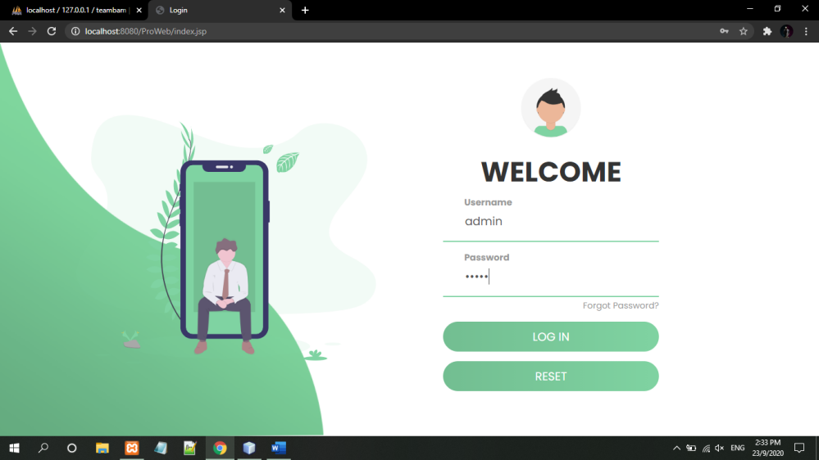

Figure 3.2.1 Login Admin

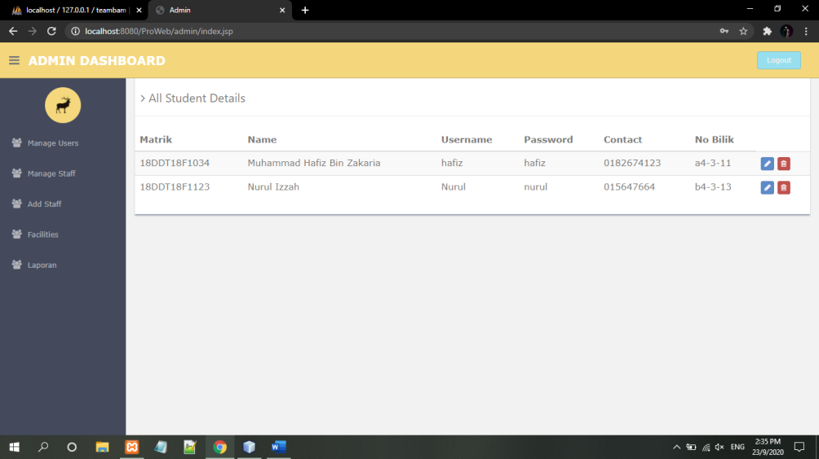

Figure 3.2.2 Student details

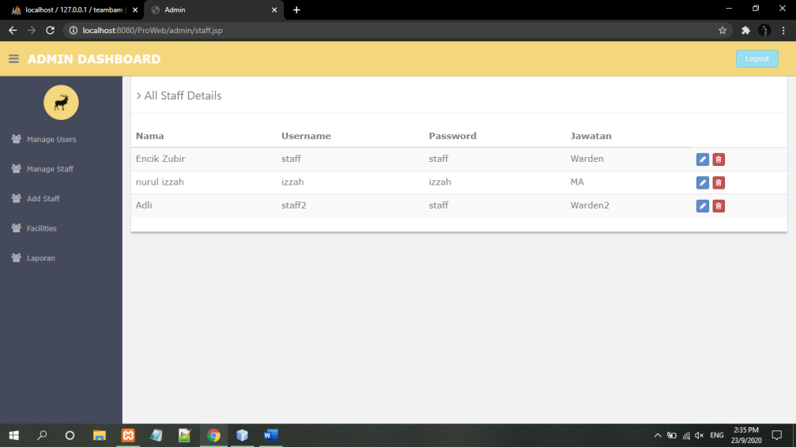

Figure 3.2.3 Staff Details

28

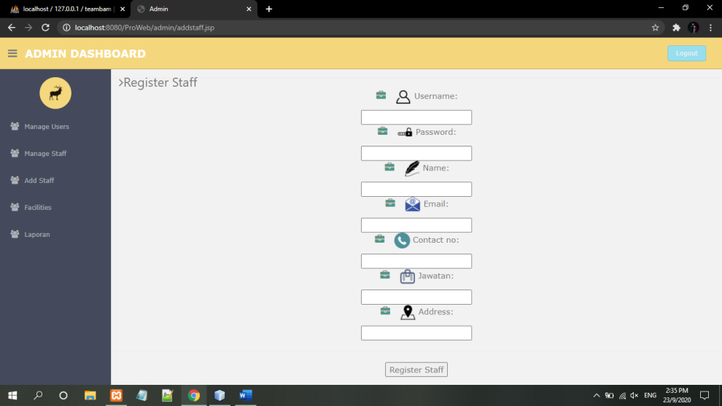

Figure 3.2.4 Register Staff

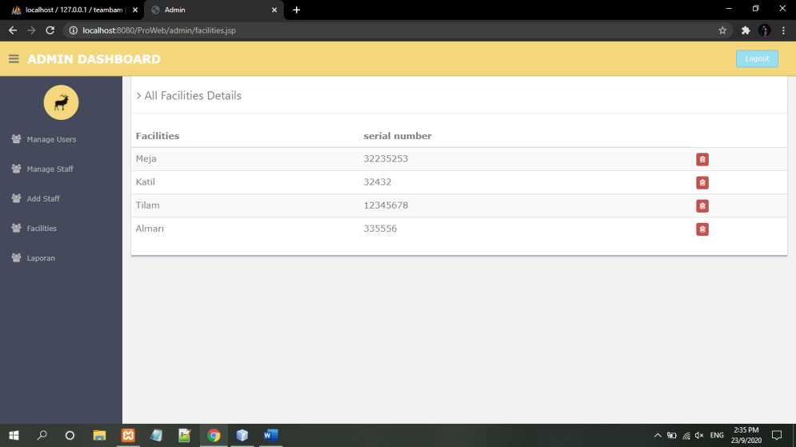

Figure 3.2.5 Facilities Details

29

Staff Page

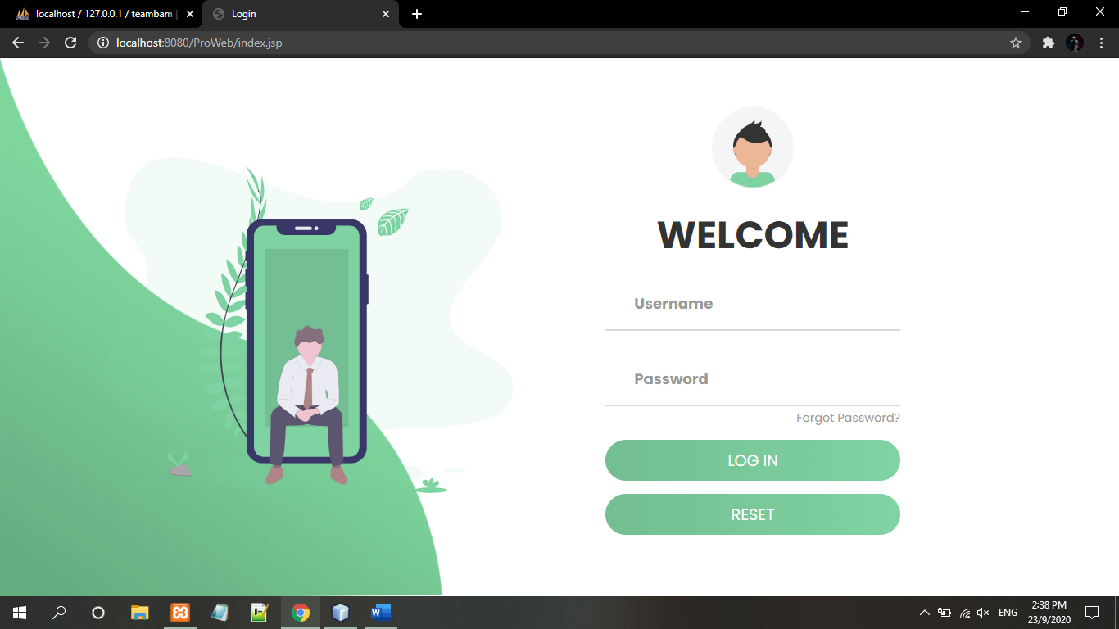

Figure 3.2.6 Login Staff

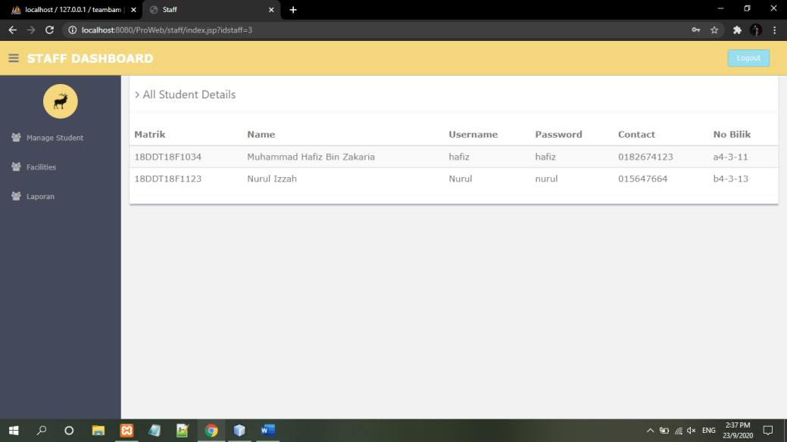

Figure 3.2.7 Student Details

30

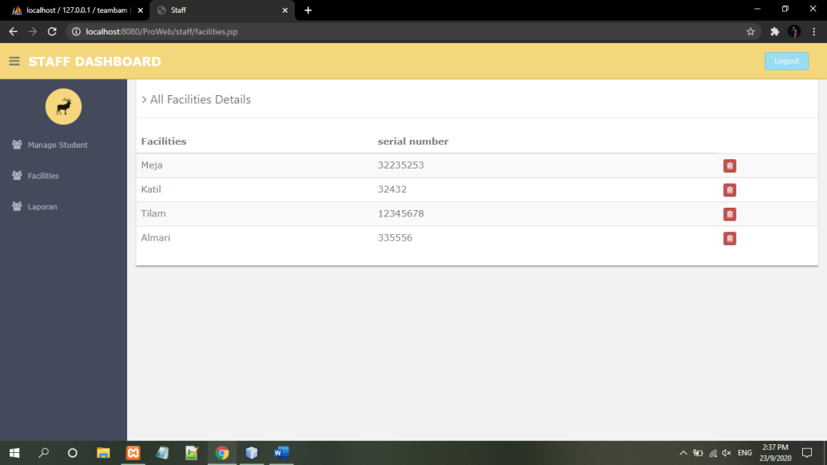

Figure 3.2.8 Facilities Details

31

Student page



Figure 3.2.9 Login Students

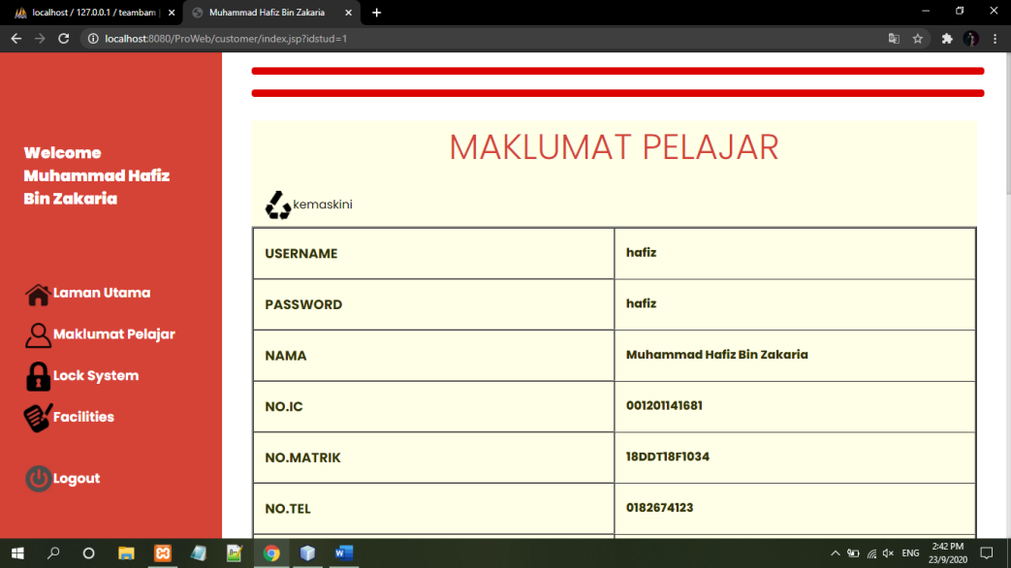

Figure 3.2.10 Info Students

32

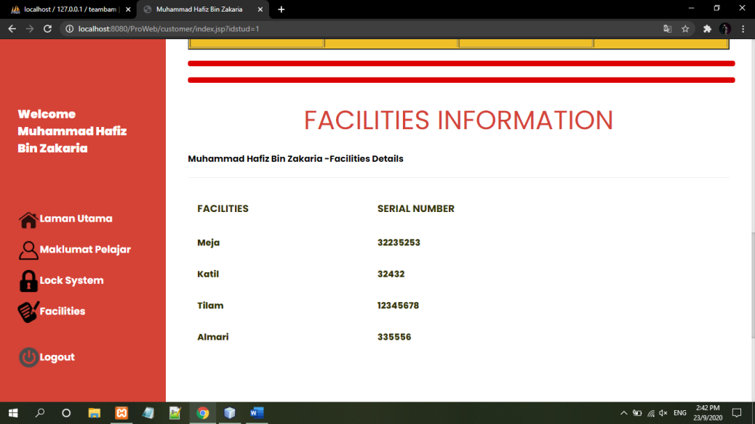  
Figure 3.2.11 Facilities information

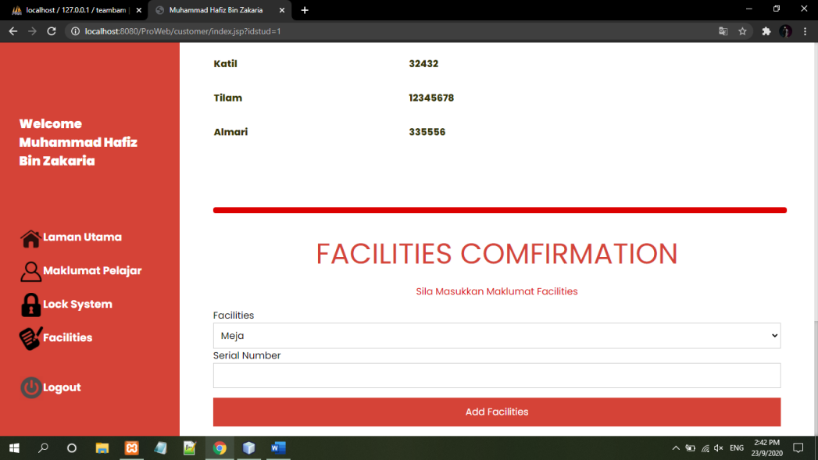

Figure 3.2.12 Facilities comfirmation

33

**4.0 TEST DESCRIPTION AND RESULTS**

**4.1** Unit Testing Plan

**Essentially, a unit test is a method that instantiates a small portion of our application and verifies its behavior independently from other parts.**



Figure 4.1. Login

35

4.2 **Integration Testing Plan**

|  |
| --- |
| WEB SYSTEM INTEGRATION TESTING PLAN (UTP) |

|  |  |  |  |  |  |  |
| --- | --- | --- | --- | --- | --- | --- |
| No | Test Case  Name | Test  Procedure | Pre-  Condition | Expected  Result | Tester | Result  (Pass/Failure) |
| 1. | Login | User is required to fill the username and password.Also,click  Button after fill username and password to access the system. | Username and password are already set in system without registration. | User will directly go to homepage after login. | Hafiz | Pass |
| 2. | Logout | User logout from the system by click logout button. | None | User will directly go to login page after clicking button logout. | Izzah | Pass |
| 3. | Update | Admin can update data staff and student.Click Button update. | Staf details and students details are already set in system. Click button Update to change data. | notifications wil review pop up and the data will change automatically in user page. | Kedah to Selangor | Pass |
| 4. | Delete | Admin can delete data staff and student.Click Button delete. | Staf details and students details are already set in system. Click button Update to change data. | notifications wil review pop up and the data will delete automatically in user page. | none | Pass |

Table 4.2 Web System Integration Testing Plan(ITP)

**36**